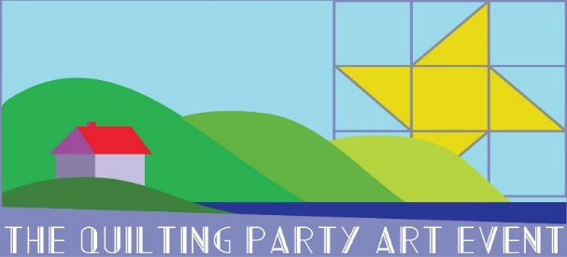
Registration Form 2019
Blueberry Ridge Retreat at Mountain Lake
Sunday April 7 to Friday April 12, 2019

Your name: Preferred first name on nametag:
Address:
City/State/Zip Code:
Home phone/cell phone number: Email:
Registration fee (non-refundable) includes lodging, your private work table in the Conference Center, and breakfast.
Optional daily short demos on art, design, and free-motion quilting as well as daily “evaluation sessions” are also offered.
Sunday dinner and Monday lunch will be potluck, please bring a dish to share.
To keep costs low participants are asked to join with other participants to provide one to two meals for the remaining days.
Accommodations: private or shared room in cabin with free Wi-Fi, towels, heat, AC; communal kitchen and main room.
Please choose:
___ Double occupancy, shared King bed with adjoining bathroom (registration fee: $550)
___ Double occupancy, two Queen beds per room with adjoining bathroom (registration fee: $575)
___ Private room, King bed with adjoining bathroom (registration fee: $825)
I would like to share a room with:
Please note: An optional daily overnight car parking rate of $10 is NOT included in the registration fee. Free parking is available off Mountain Lake Lodge premises.
Refund policy: Registration fee is non-refundable. In the event that you are no longer able to attend, you may find someone else to take your place. You may also inquire if a waiting list exist. Please contact Karin about any changes. We reserve the right to cancel if our minimum requirement of attendees is not reached. If that occurs you will receive a full refund.

A NON-REFUNDABLE $ 250 deposit per person is required at the time of registration to reserve your space.
Any outstanding balance is due on or before November 30, 2018.
After November 30, 2018 payment in full is required at the time of registration.

Space is limited. To register, complete the form and mail with a check payable to “The Quilting Party Art Event” to:

Karin Tauber
6104 Albemarle Lane email: KUTauber@aol.com
Blacksburg, VA 24060 phone: 540-961-5222

If you have not received an email confirmation within 3 weeks, please contact Karin to verify your information
Liability Waiver and Indemnification Agreement: To the maximum extent of the law, your attendance and participation in any The Quilting Party Art Event is conditioned on your agreement to hereby indemnify The Quilting Party Inc., its employees, volunteers, and contractors from, and never to make any claim for injury, loss, or damage to you against the Quilting Party Inc. its employees, volunteers, and contractors, caused by its very first negligence, strict liability, or for any other reason.

Your registration cannot be processed without your signature on this line. ____________________________________

For full information go to http://kutauber.wixsite.com/the-quilting-party/blueberry-ridge-retreat

