REGISTRATION FORM
Wool Applique with Sandra Fraenkel
July 12, 2023 0900 - 1200

Blacksburg Presbyterian Church, Church Street, Blacksburg.
Enter on Eaton Street and proceed to the Fellowship Hall. IN PERSON

If you have been admiring all of the wool appliqué pieces in quilt shows or in quilt shops but would like to know how the techniques for this style, this is the workshop for you ! Sandra will cover where to find quality supplies, the difference between felted wool and felt, how to prepare your designs for appliqué, how to adapt traditional quilting motifs for wool appliqué, basic stitches, the variety of threads and their different visual effects… an all around good understanding of wool appliqué. All skill levels.
Limited to 20 participants.

Kit (includes pre-constructed pincushion top, heat n bond, batting, backing, thread, wool, needle and directions).
Supply list: Pencil
Sharp small scissors
Needle threader (optional)
KIT Fee payable to instructor $10.00
Workshop Fee $25.00 MINIMUM TEN (10) STUDENTS required

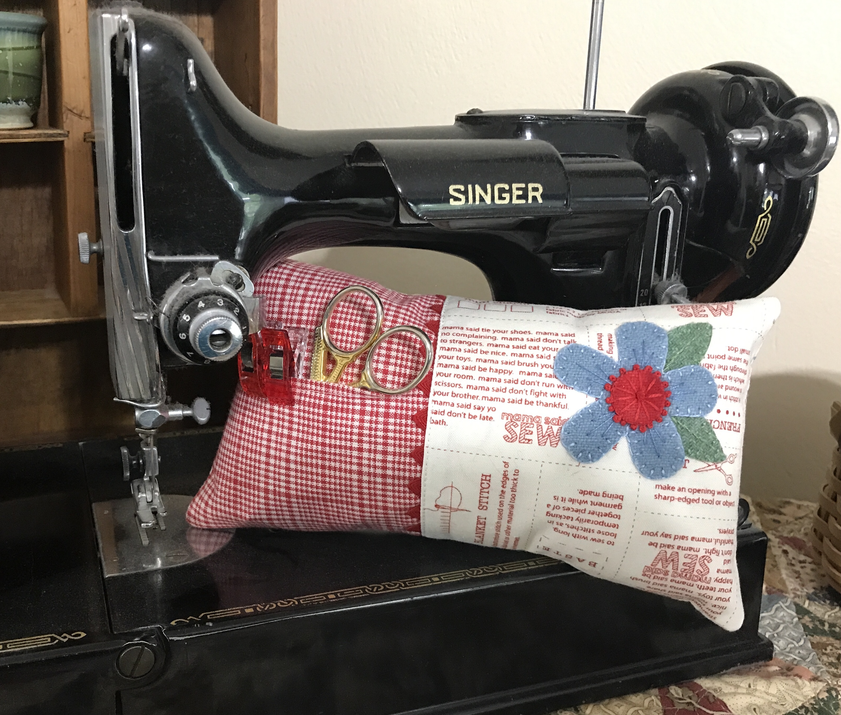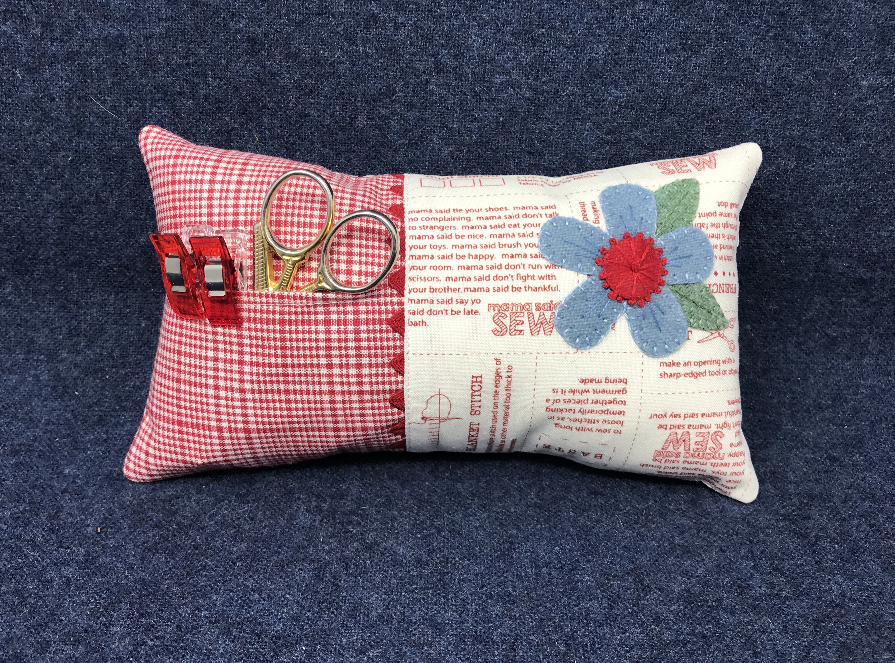

(Cut along stars and return to Paula Golden no later than June 30, 2023)
** ** ** ** ** ** ** ** ** ** ** ** ** ** ** ** **

NAME __________________________________________________________
ADDRESS _______________________________________________________
EMAIL ADDRESS _________________________________________________
PHONE NUMBER _________________________________________________
Payment via check made payable to The Quilting Party for $25.00
Mail to: Paula Golden, 2095 Plank Drive, Blacksburg, Virginia 24060

